Project Planning Phase
Project Planning Template (Product Backlog, Sprint Planning, Stories, Story points)

Date | 25 JAN 2026
Team ID | LTVIP2026TMIDS72167
Project Name | Strategic Product Placement Analysis: Unveiling Sales Impact with Tableau Visualization
Maximum Marks | 5 Marks

Product Backlog, Sprint Schedule, and Estimation (4 Marks)
Use the below template to create product backlog and sprint schedule

Sprint | Functional  Requirement (Epic) | User Story  Number | User Story / Task | Story Points | Priority | Team  Members
Sprint-1 | Data collection | USN-1 | Collection of data | 3 | High | NIkhil
Sprint-1 | Data Understanding | USN-2 | Understanding data | 2 | medium | Nikhil
Sprint-1 | Data Handling | USN-3 | Connecting the data set with tableau | 2 | medium | Nikhil
Sprint-2 | Data preparation | USN-1 | Prepare the data for visulization | 3 | High | Varun Aditya
Sprint-3 | Data visualization | USN-1 | No.of unique vizulation | 3 | High | Varun Aditya
Sprint-3 | Dashboard | USN-1 | Create of dashboard | 3 | High | Sai Kumar
Sprint-4 | story | USN-1 | Create story | 2 | medium | Sai Kumar
Sprint | Performance testing | USN-1 | testing | 2 | medium | Sai Kumar

Project Tracker, Velocity & Burndown Chart: (4 Marks)

Sprint | Total Story Points | Duration | Sprint Start Date | Sprint End Date (Planned) | Story Points Completed (as on  Planned End Date) | Sprint Release Date (Actual)
Sprint-1 | 7 | 6 Days | 16 JAN 2026 | 22 JAN 2026 | 7 | 22 JAN 2026
Sprint-2 | 2 | 6 Days | 18 JAN 2026 | 24 JAN 2026 | 3 | 24 JAN 2026
Sprint-3 | 6 | 6 Days | 20 JAN 2026 | 26 JAN 2026 | 6 | 26 JAN 2026
Sprint-4 | 4 | 6 Days | 21 JAN 2026 | 27 JAN 2026 | 4 | 27 JAN 2026

Velocity:
Total Story Points
Sprint 1 = 7
Sprint 2 = 3
Sprint 3 = 6
Sprint 4 = 4

Velocity= Total Story Points Completed/ Number of Sprints Total story Points= 7+3=6+4 =20
No of Sprints= 4
Velocity = (16+8)/2= 20/4 5 (Story Points per Sprint)
Your team’s velocity is 5 Story Points per Sprint.

Time line:

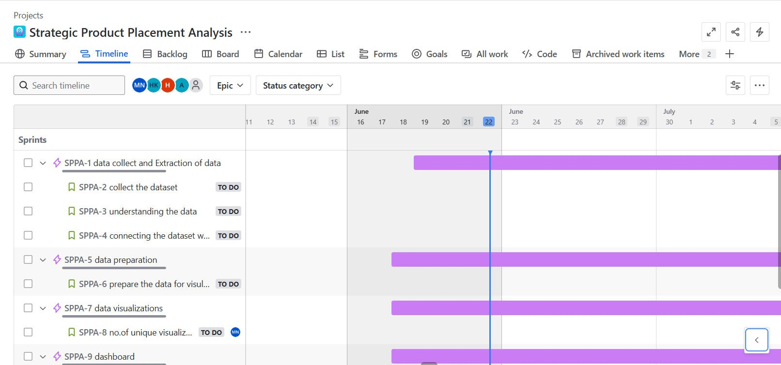

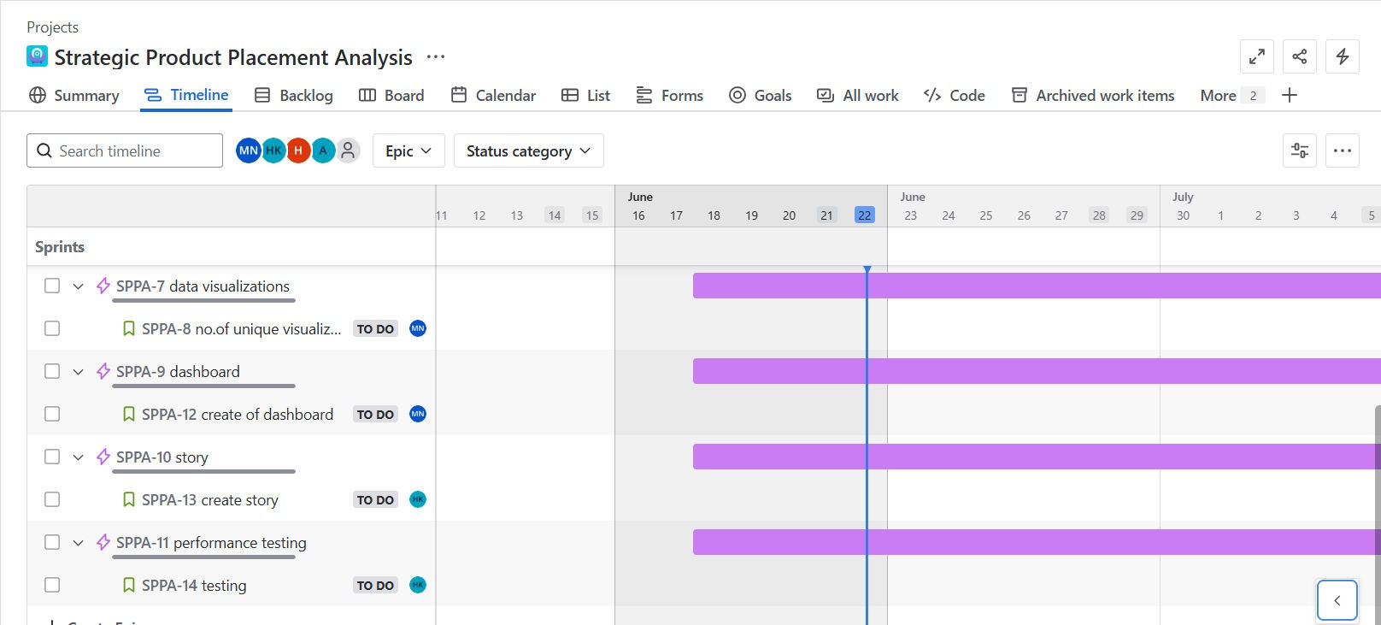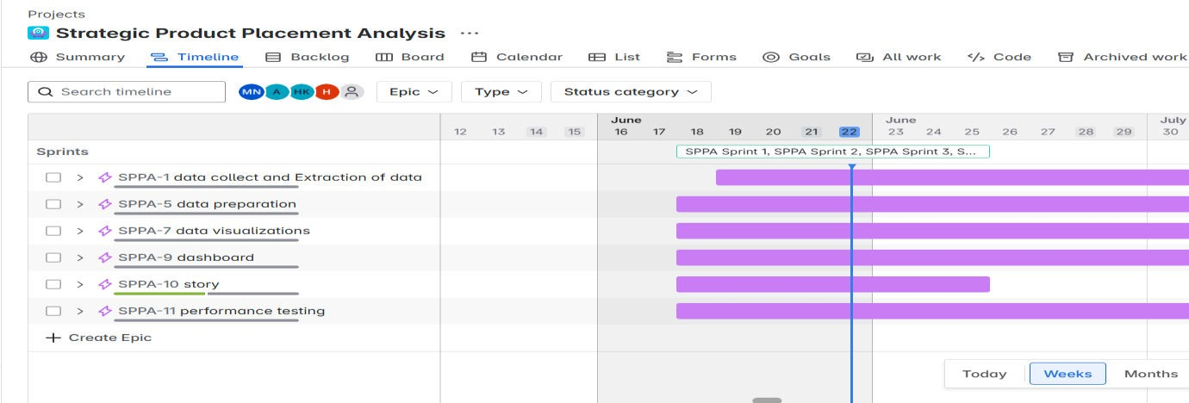

Backlog:

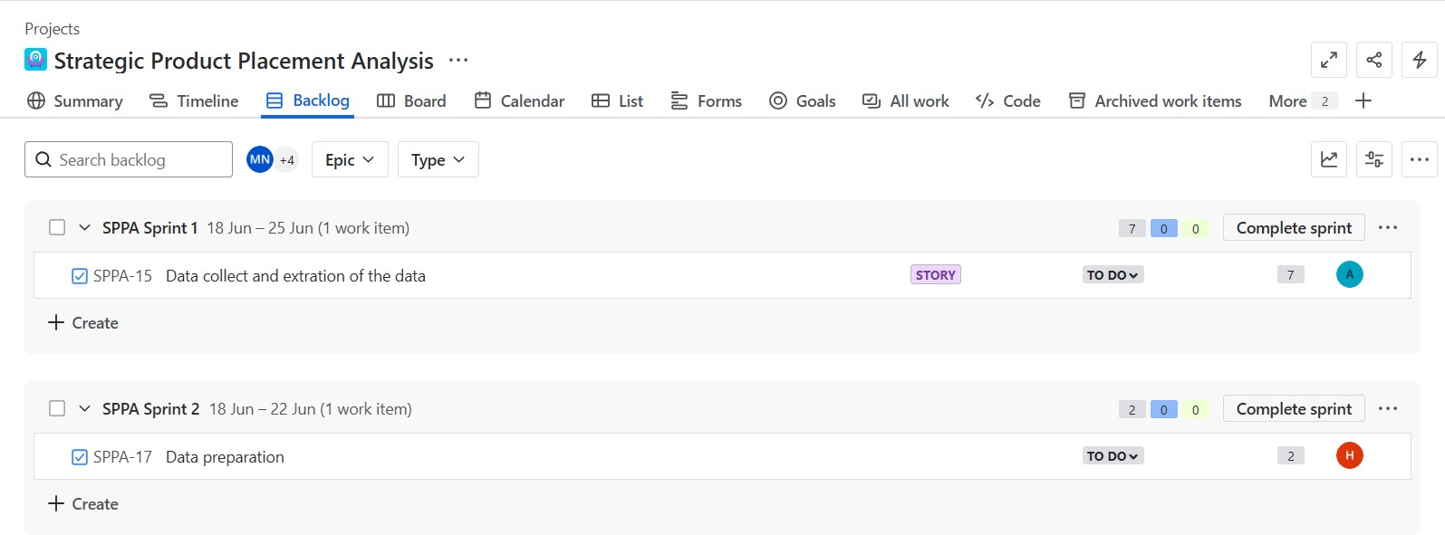
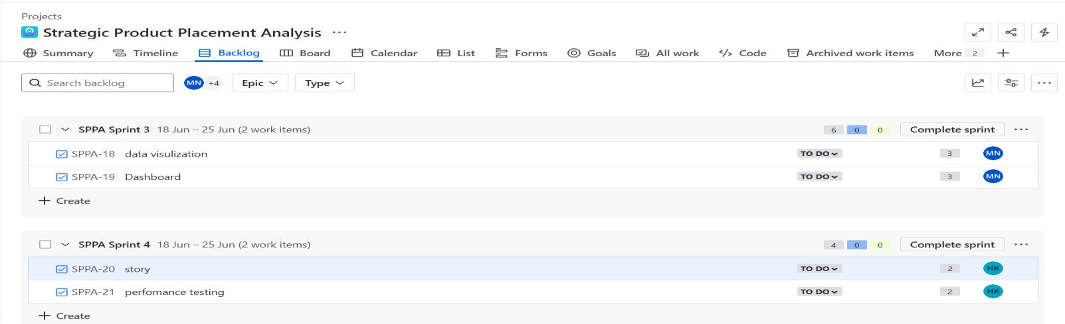

Board:
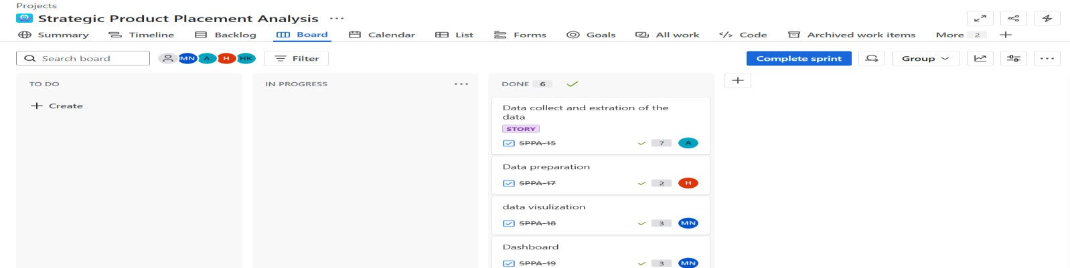

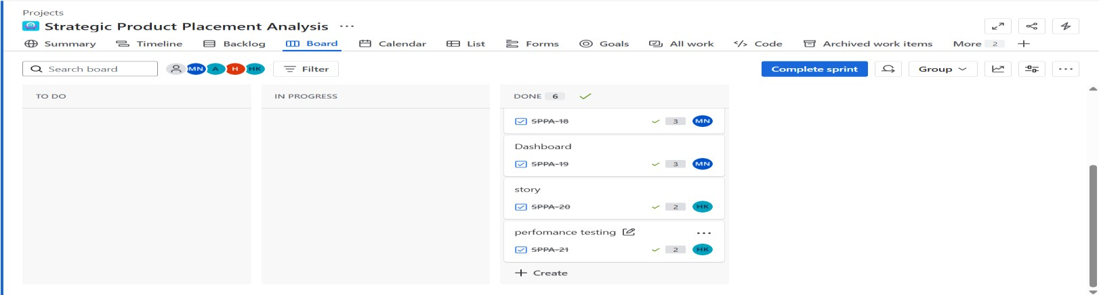

Burndown Chart:
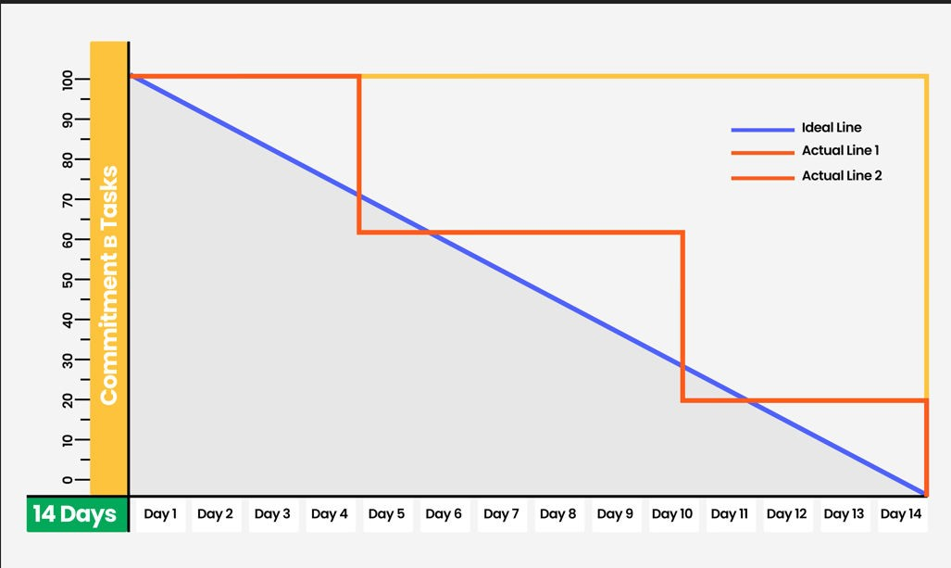

A burn down chart is a graphical representation of work left to do versus time. It is often used in agile software
development methodologies such as Scrum. However, burn down charts can be applied to any project containing measurable progress over time.

https://www.visual-paradigm.com/scrum/scrum-burndown-chart/ https://www.atlassian.com/agile/tutorials/burndown-charts

Reference:
https://www.atlassian.com/agile/project-management https://www.atlassian.com/agile/tutorials/how-to-do-scrum-with-jira-software https://www.atlassian.com/agile/tutorials/epics https://www.atlassian.com/agile/tutorials/sprints https://www.atlassian.com/agile/project-management/estimation https://www.atlassian.com/agile/tutorials/burndown-charts

